|  |
| --- |
| **FURTHER EDUCATION AND TRAINING CERTIFICATE: INFORMATION TECHNOLOGY: SYSTEMS DEVELOPMENT**  **ID 78965 LEVEL 4 – CREDITS 165** |
| **LEARNER GUIDE**  **SAQA: 14933**  **Demonstrate an understanding of creating multimedia/web-based computer applications with scripting** |

**Learner Information:**

|  |  |
| --- | --- |
| **Details** | **Please Complete this Section** |
| Name & Surname: |  |
| Organisation: |  |
| Unit/Dept: |  |
| Facilitator Name: |  |
| Date Started: |  |
| Date of Completion: |  |

**Copyright**

All rights reserved. The copyright of this document, its previous editions and any annexures thereto, is protected and expressly reserved. No part of this document may be reproduced, stored in a retrievable system, or transmitted, in any form or by any means, electronic, mechanical, photocopying, recording or otherwise without the prior permission.

# Key to Icons

The following icons may be used in this Learner Guide to indicate specific functions:

|  |  |
| --- | --- |
| **http://www.duluth.lib.mn.us/Images/BookStack.gif**  **Books** | **This icon means that other books are available for further information on a particular topic/subject.** |
| http://www.rpsrelocation.com/_borders/checklist.jpg  **References** | **This icon refers to any examples, handouts, checklists, etc…** |
| http://www.school-portal.co.uk/GroupDownloadAttachment.asp?GroupId=21353&AttachmentID=1300079**Important** | **This icon represents important information related to a specific topic or section of the guide.** |
| **http://cloud.graphicleftovers.com/11976/item34004/Cartoon-exercise-book.jpgActivities** | **This icon helps you to be prepared for the learning to follow or assist you to demonstrate understanding of module content. Shows transference of knowledge and skill.** |
| http://3.bp.blogspot.com/_0EodaYtqevU/TMun5XOj03I/AAAAAAAAAIU/lzrnWelQjgc/s1600/group-discussion.jpg**Exercises** | **This icon represents any exercise to be completed on a specific topic at home by you or in a group.** |
| **http://edtech.kennesaw.edu/intech/images/rubric.gif**  **Tasks/Projects** | **An important aspect of the assessment process is proof of competence. This can be achieved by observation or a portfolio of evidence should be submitted in this regard.** |
| **http://tell.fll.purdue.edu/JapanProj/FLClipart/Adjectives/busy.gifWorkplace Activities** | **An important aspect of learning is through workplace experience. Activities with this icon can only be completed once a learner is in the workplace** |
| http://blog.mindjet.com/wp-content/uploads/2010/01/helpful_tips_image.jpg**Tips** | **This icon indicates practical tips you can adopt in the future.** |
| http://school.discoveryeducation.com/clipart/images/read.gif**Notes** | **This icon represents important notes you must remember as part of the learning process.** |

# Learner Guide Introduction

|  |  |
| --- | --- |
| **About the Learner Guide…** | This Learner Guide provides a comprehensive overview of the **Demonstrate an understanding of creating multimedia/web-based computer applications with scripting,** and forms part of a series of Learner Guides that have been developed for **FURTHER EDUCATION AND TRAINING CERTIFICATE: INFORMATION TECHNOLOGY: SYSTEMS DEVELOPMENT ID 78965 LEVEL 4 – CREDITS 165** The series of Learner Guides are conceptualized in modular’s format and developed for **FURTHER EDUCATION AND TRAINING CERTIFICATE: INFORMATION TECHNOLOGY: SYSTEMS DEVELOPMENT ID 78965 LEVEL 4 – CREDITS 165** They are designed to improve the skills and knowledge of learners, and thus enabling them to effectively and efficiently complete specific tasks.  Learners are required to attend training workshops as a group or as specified by their organization. These workshops are presented in modules, and conducted by a qualified facilitator. |
| **Purpose** | * **Demonstrate an understanding of creating multimedia/web-based computer applications with scripting** |
| **Outcomes** | At the end of this module, you will be able to:   * **Demonstrate an understanding of creating multimedia/web-based computer applications with scripting** |
| **Assessment Criteria** | The only way to establish whether a learner is competent and has accomplished the specific outcomes is through an assessment process.  Assessment involves collecting and interpreting evidence about the learner’s ability to perform a task.  This guide may include assessments in the form of activities, assignments, tasks or projects, as well as workplace practical tasks. Learners are required to perform tasks on the job to collect enough and appropriate evidence for their portfolio of evidence, proof signed by their supervisor that the tasks were performed successfully. |
| **To qualify** | To qualify and receive credits towards the learning programme, a registered assessor will conduct an evaluation and assessment of the learner’s portfolio of evidence and competency |
| **Range of Learning** | This describes the situation and circumstance in which competence must be demonstrated and the parameters in which learners operate |
| **Responsibility** | The responsibility of learning rest with the learner, so:   * Be proactive and ask questions, * Seek assistance and help from your facilitators, if required. |

Learning Unit1

**UNIT STANDARD NUMBER :** 14933

**Demonstrate an understanding of creating multimedia/web-based computer applications with scripting**

**LEVEL ON THE NQF :** 4

**CREDITS :** 6

**FIELD :** Services

**SUB FIELD :** Transport, Operations and Logistics

|  |  |
| --- | --- |
| **PURPOSE:** | * This unit standard is intended for individuals who need to create, test and gain user approval for multimedia/web-based computer applications with scripting from an outlined brief of the application. * People credited with this unit standard are able to: * plan the use of a multimedia/web-based authoring computer application with scripting; * design a multimedia/web-based application; * identify and save text, graphic elements and animation to be included in the multimedia/web-based application; * create multimedia/web-based application scripts; and * assemble a multimedia/web-based application including scripts. * The performance of all elements is to a standard that allows further learning in this area |
| **LEARNING ASSUMED TO BE IN PLACE:** | |
| **Description of required skills, knowledge and understanding on:**  **Producing computer graphics using base functions**  **Automate computer processes in an application using a macro facility. .** | |

|  |
| --- |
| **SESSION 1.**  **Plan the use of a multimedia/web-based authoring computer application with scripting.** |
| **Learning Outcomes** |
| * 1. The user-specified topic, purpose, target audience and objectives of the application are identified according to agreed development plan. * 2. The tools selected to create multimedia/web-based computer applications with scripting is justified in relation to the agreed development plan * 3. The hardware and software required to create and run the application is identified according to the agreed development plan. * 4. The plan for the creation of a multimedia/web-based computer application is outlined and monitored according to project planning principles and financial requirements. * 5. The configuration of the computer and associated systems necessary for the creation of the application are identified according to the agreed development plan. |

**WHAT IS WEB-BASED MULTIMEDIA?**

Web-based multimedia refers to Web sites containing more than one type of media -- typically sound, video, or animation, in addition to text and images.  Many multimedia Web sites contain interactive elements with which the user participates directly, such as to control the delivery of a sound or video clip, manipulate a 3-D object, or play a game.   Like other types of Web pages, multimedia Web pages utilize hyperlinks for interactivity�the information presented and the order in which it is presented is determined by the hyper-links clicked by the visitor.   
  
In the past, Web-based multimedia was very limited, because computers and Internet connections were too slow to support it.  Today's fast computers and Internet connections, however, make multimedia use much more feasible.  A growing number of Web sites include multimedia components and their use is expected to continue to increase.

**ADVANTAGES AND DISADVANTAGES OF USING MULTIMEDIA**

Perhaps one of the biggest advantages of using multimedia is that it can fit a variety of learning styles.  Some people are visual learners, who learn best by seeing; others are auditory learners, who leam best by hearing.   Still others are kinesthetic learners who learn best by doing.   When a single medium is used, although it may be appropriate for some users, other users may be missing out on the full experience simply because the application doesn't match their learning styles.  Multimedia has the advantage of presenting the material in multiple learning styles, which helps to alleviate this problem.   
  
For example, an interactive Web-based exercise that uses printed text, images, spoken narration, and activities that the user performs covers the three types of learning styles just discussed.  Studies have shown that when multiple learning styles are used, learning is enhanced.  This benefit is applicable to more than just educational Web sites.  For instance, a manufacturer could include multimedia on its Web site to try to convince visitors that its product is superior�the manufacturer would want this message to reach and be understood by as many visitors as possible.   
  
Other advantages of multimedia use are that it often makes the presented material more interesting and enjoyable, and many ideas are easier to convey in multimedia format.  For an example, compare listening to the news on the radio to watching the news on TV.  The addition of the visual image of the newscaster combined with video clips, photographs, and other graphics typically used on TV news broadcasts usually makes watching the news on TV a more informative experience for most individuals than listening to a radio news broadcast.  Another example is shown in  [Figure 10-1](http://www.mtsac.edu/~rpatters/CISB11/Chapters/Chapter_10/Figures/Fig10-01.jpg" \o "Click here to see Figure 10-1." \t "_blank).  This children's multimedia arts and craft program includes videos and photos to illustrate how to create each craft.   Compare that medium to the printed directions shown in the figure -- the multimedia version should be much more effective in teaching children how to create the craft than the text-only version.   
 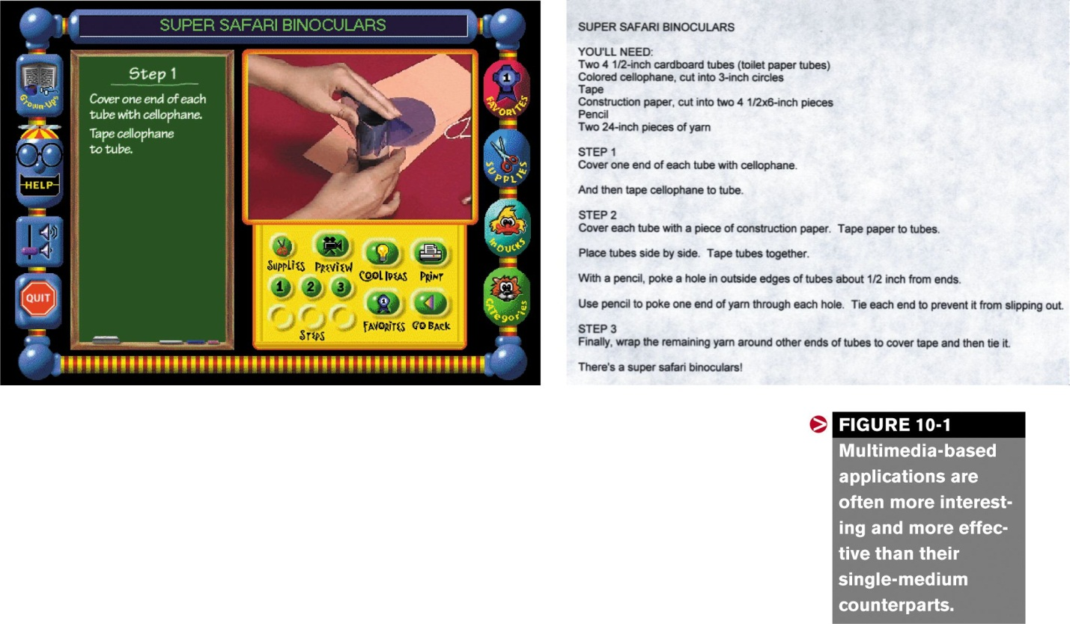  
One disadvantage to using multimedia is cost.  Multimedia Web sites are usually quite a bit more expensive and time-consuming to create than a simple text-and-image format.  Although multimedia elements for a Web site can be created in-house (if an employee has the necessary skills and experience with multimedia software), many businesses opt to out-source the development of their multimedia Web site to a professional development firm, which tends to add to the expense.  Other possible limitations of multimedia include that its delivery may be slower than text-only content, which may annoy some dial-up Internet users, and that some components may not be compatible with all devices, browsers, and Internet connection speeds used by visitors.   These factors need to be considered when a multimedia Web site is created,

**Determining the Intended Audience and Objectives**

One of first steps in designing a multimedia application or Web site should be determining the intended audience and the primary objectives of the site.   The intended audience must be considered at the design stage because it greatly affects the appearance (such as the style, graphics, fonts, and colors) you will select for the site.  For example, four sites designed to appeal to distinctly different audiences are shown in  [Figure 10-10](http://www.mtsac.edu/~rpatters/CISB11/Chapters/Chapter_10/Figures/Fig10-10.jpg" \o "Click here to see Figure 10-10." \t "_blank).   
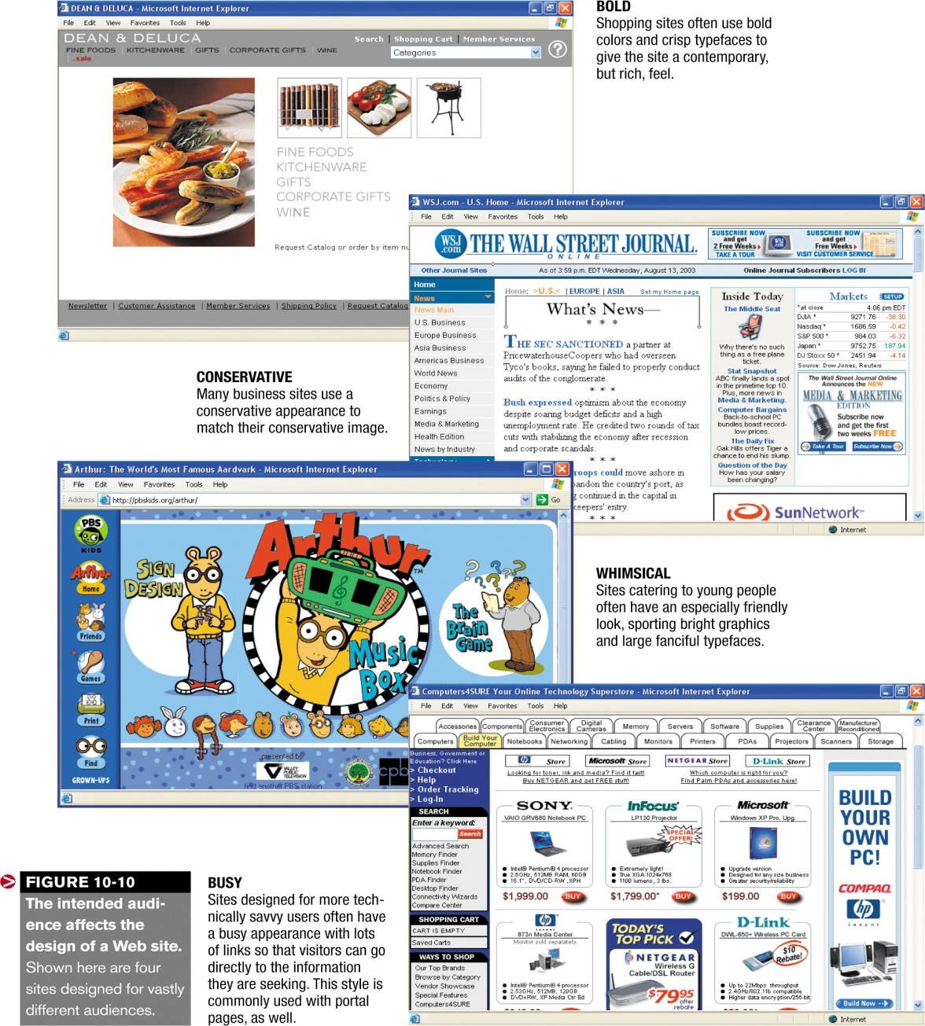  
The intended audience also affects the types of multimedia elements that can be included on a site.  If you are designing a site to be accessed through an intranet, for example, you don't have to be as concerned about file size as someone designing a Web site to be accessed by the general public.  When determining your target audience, give some thought to how users will access the site and how technologically savvy they are.  Will they be using up-to-date browsers and have a variety of multimedia plug-ins installed? If your answer is "no," that impacts the types of multimedia elements you should include on the site.  The objectives of the site also affect the content of the site because you will want to make sure that the site includes the information needed to meet the site objectives.   
  
Once the audience and objectives have been identified, you should have a good idea of the main topics that need to be included in the site.   If you don't, don't go any further into the design process until you do.  Rethink your audience and objectives, explore other sites on the Web, and talk to potential users until you understand what the site's content should include.

**NB- ASSESEMENT CRITERIA NOT COVERED IN SESSSION 1 REFER TO SESSION 2**

|  |
| --- |
| **SESSION 2.**  **Design a multimedia/web-based computer application.** |
| **Learning Outcomes** |
| * 1. Multimedia/web-based application design is generated according to the user specifications of the multimedia/web-based application.Range: The multimedia/web-based application refers to the user specifications for the topic, purpose, target audience and objectives. * 2. Story-board and flow-diagram of the multimedia/web-based computer application is designed to ensure effective communication between developer and user understanding. * 3. The multimedia/web-based computer application is designed according to effective communication for multimedia/web-based in the application principles. |

**MULTIMEDIA WEB SITE DESIGN**

Web *site design* refers to the process of planning what your Web site will look like and how it will work.  Although this chapter focuses on designing and developing multimedia Web sites, the process of designing stand-alone multimedia applications, such as those delivered via a CD or kiosk, and non-multimedia Web sites are similar in many respects.   In all instances, the importance of careful planning cannot be overemphasized.   Time spent planning and designing a site on paper before jumping into the development process pays off in the long run.  Some of the most important design considerations and guidelines are discussed next.

**Basic Design Principles**

When designing a multimedia Web site, it is important to keep two basic principles in mind: (1) Users like interesting and exciting applications; and (2) users have little patience with slow-to-load or hard-to-use applications.   
  
A site is *interesting* if it provides information of value or interest to its target audience; users find it *exciting* if it rewards them with a stimulating experience.  Unfortunately, interest and excitement wear off over time.  If visitors see the same information at your site day after day or week after week, boredom sets in and they will likely stop visiting.  Therefore, it is important to refresh the content of your site regularly with new information.   
  
Web site visitors generally don't have much patience with poorly designed sites.  So, if they have a hard time figuring out how to navigate a site to get the information they want or if pages on the site take too long to load, they often move on to another site and may never return.   To facilitate navigation and reduce user frustration, you should design an intuitive site with clear, consistent navigational tools and information presented in a manner that makes sense.  Web pages should load quickly and be easy to read -- a good rule of thumb is to keep the total file size of a page (the Web page file, plus image files and any other multimedia elements displayed on the page) to 30 KB to enable the page to load in 30 seconds or less for all users.  To accomplish this, you need to select your multimedia elements carefully and modify them as necessary to be as efficient as possible.   
  
Another factor that impacts the design of a Web site is the device that your target audience will use to access the site.  Since it can vary from a large screen TV to a 17-inch desktop PC montior to a handheld PC with a 2-inch screen to a smart phone, obviously a one-size-fits-all Web site is not an acceptable option.  At a minimum, decide early on whether the site will be used for conventional PCs (with screen sizes ranging from about 10 inches and up), whether the site will be designed for handheld or portable device use, or whether content will be optimized for multiple delivery methods.   
  
Even if a single delivery method is assumed (such as a conventional PC), there are still many variations of platforms.  Web browsers, and settings that can be used by Web page visitors.  Because of this, it is important to set up the site so it can be used on as many different PC configurations as possible.  Careful consideration should be given to: 

* *Features that require a specific browser*.  Including snazzy animated effects for Internet Explorer users might be nice for them, but ignores other users.  Browser standards are growing more closely together, but there are still features not supported by all browsers.  At the present time, you can either not use browser-specific features or use them for what should be your target audience's most widely used browser, as long as it doesn't inhibit the functionality of the application for other users.  Or you can choose to identify the browser used by each visitor (using JavaScript code on the home page of the site) and display a version of your site that matches the visitor's browser.
* *Features that require little used plug-ins*.  Although it is annoying to have to download a plug-in before being able to use a Web page feature, most users tolerate downloading a few of the most widely used plug-ins (such as Acrobat Reader, Flash Player, Shockwave Player, and QuickTime Player) the first time they are needed, if they don't have them already installed.   Don't annoy your visitors by requiring unusual plug-ins that they may not have or have no other reason to obtain.
* *The size of the page content*.  Keep in mind that different browsers and screen resolutions allow different amounts of room to display Web page text.  This affects how wide your images and columns of text should be.   To ensure that the content is visible on virtually all PCs with a maximized browser window and a screen resolution of 800 x 600 or higher, without the user having to scroll down unnecessarily, keep banner images, image maps, and other full-width items to 710 pixels or less.  Full-height items (such as an image map) should be less than 420 pixels tall.
* *High-handwidth items*.  Although broadband Internet use is growing, there is still a huge installed base of dial-up modem users.  If the intended audience of your site includes a large number of dial-up users, pay extra close attention to the size of the images on the site, and use techniques to allow the user to decide whether to take the time to access certain features of the site.  For example, instead of automatically downloading and playing a sound or video file, have a link to it (with an estimated download time listed).  When large images are needed, use thumbnail images that the user can click to display the full-sized image only when needed.  Also, use streaming audio and video files whenever possible.  Finally, be sure that all multimedia elements are consistent with the purpose of your site and add something significant.  Don't add extra elements -- particularly sound and video files�without a good reason.   They just slow down your site and annoy your visitors.

**Using Flowcharts, Page Layouts, and Storyboards**

After the intended audience, objectives, and basic content to be included in a Web site have been determined, the structure and layout of the site can be designed.  To this end, **tools such as *flowcharts*, *page layouts*, and *storyboards*** are often used.   
  
A **flowchart**, when used with the design of a Web site, describes how the pages in the site relate to one another.  The top part of [Figure 10-11](http://www.mtsac.edu/~rpatters/CISB11/Chapters/Chapter_10/Figures/Fig10-11.jpg" \o "Click here to see Figure 10-11." \t "_blank) shows a flowchart for a bed and breakfast Web site.   Note that each box in the flowchart represents a separate Web page, and the lines between boxes show which pages logically relate to others.   Remember, however, that you can link pages in any way you like.   Although the lines between the flowchart boxes indicate logical hyperlinks, there would typically be additional links between the pages.   For example, it is a good idea to place links to the main pages of the site (in this example.  Home, Rooms, Maps, About Three Rivers, and Reservations) on all pages of the site. 

For designing the layout of a Web page or multimedia component, either **page layouts** (for Web pages) or a **storyboard** (for multimedia components) are typically used.  Both tools are sketches�done by hand or with the help of a computer�that illustrate the layout and navigational structure of the site or application.  For Web sites, typically two page layouts are created: one for the home page (see the bottom screen in  [Figure 10-11](http://www.mtsac.edu/~rpatters/CISB11/Chapters/Chapter_10/Figures/Fig10-11.jpg" \t "_blank" \o "Click here to see Figure 10-11.)) and one to be used for all other pages on the site.   For multimedia components, such as a game or product demo, a storyboard -- an ordered series of sketches of each page or screen -- might be used.  For a look at how storyboards and computers are used to create animated feature films, see the Inside the Industry box.

**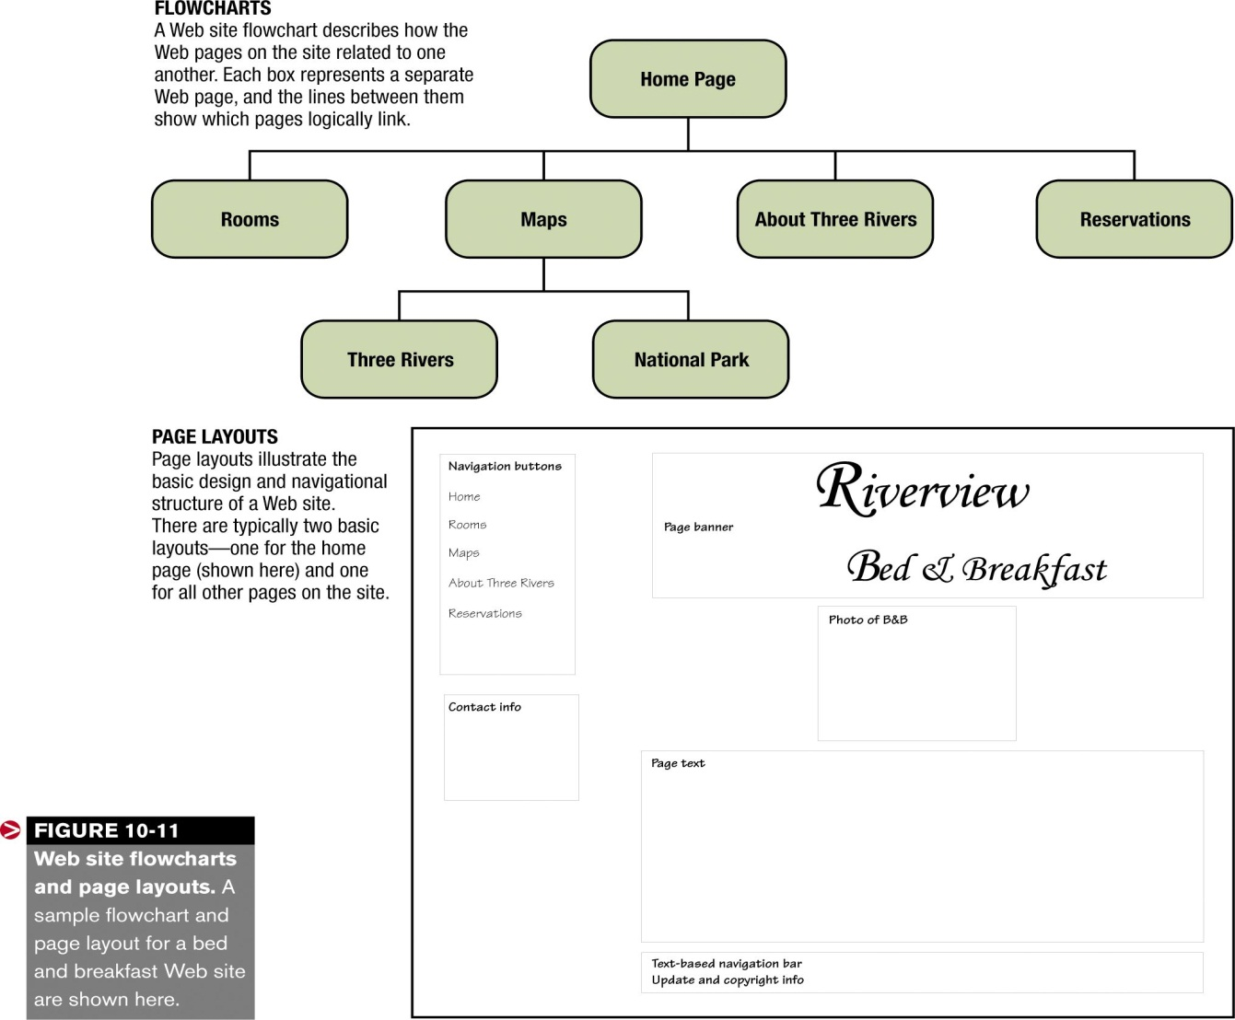**

**Navigational Design Considerations**

As already mentioned, careful design of your navigational structure is extremely important.  After drawing a preliminary flowchart of a site or application, take a look at the balance of the flowchart.    For Web sites, users should be able to get to most pages on the site within three mouse clicks.  For large sites, navigational tools such as drop-down menus, *site maps* (table of contents pages for sites that contain links to all main pages on the sites), and search boxes can help accomplish this.  Other navigational options include text-based hyperlinks and navigation bars; image-based navigation bars; *image maps* (single images with separate areas linked to different locations); *frames* (with one frame always displaying the navigation bar and the other frame displaying the site contents as navigational links are clicked); and hyper-links that display more options or a description of the link when pointed to.  Some examples of these navigational elements are shown in  [Figure 10-12](http://www.mtsac.edu/~rpatters/CISB11/Chapters/Chapter_10/Figures/Fig10-12.jpg" \o "Click here to see Figure 10-12." \t "_blank).  When designing your navigational structure, be sure to place the same navigational items in the same location on every page, so that users can easily find them.  Also be sure that any icons or other graphics are easily understood.  When in doubt, add a text name to the image, such as the icons (Personalize and Finance, for instance) on the Yahoo! banner shown in [Figure 10-3](http://www.mtsac.edu/~rpatters/CISB11/Chapters/Chapter_10/Figures/Fig10-03.jpg).   In addition, if an image or text looks like it's a hyperlink, it should be one.  For that reason, don't underline non-linked text.   
  
For long Web pages, consider separating the content into several pages to reduce scrolling and loading time; the pages are typically viewed using some type of "Back" and "Next" button or with a linked table of contents (refer again to  [Figure 10-12](http://www.mtsac.edu/~rpatters/CISB11/Chapters/Chapter_10/Figures/Fig10-12.jpg)).  When you break a large document apart, consider including a link to view or download the entire document intact either as a Web page or in a common format, such as Word or PDF, so that users can read or print the entire document at one time.  For long Web pages that can't be broken into multiple pages, include a table of contents at the top of the page that allows users to jump down to a particular section of the document, and periodically include a link that jumps users back to the top of the page.   
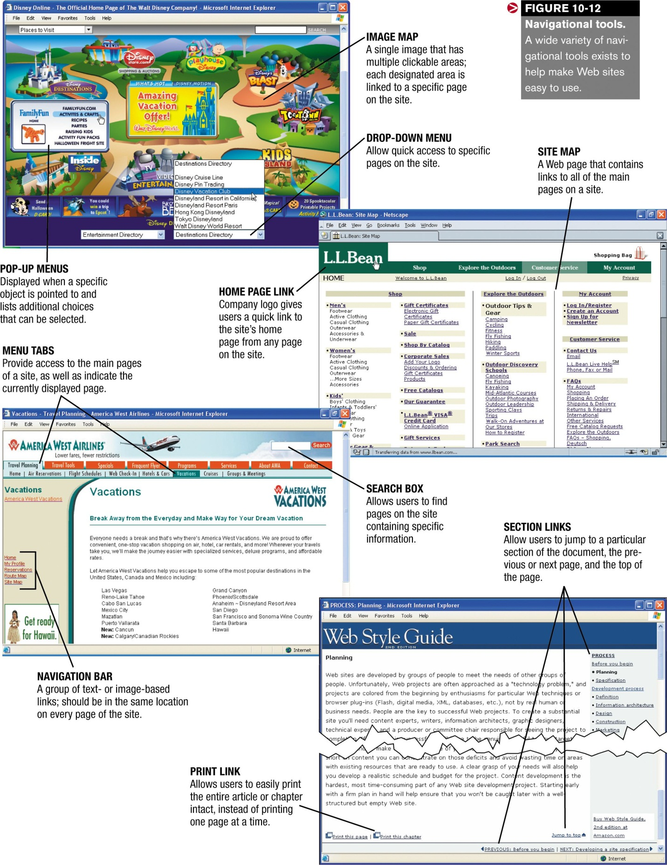  
One final navigational hint: Be sure to include identifying information on each page of the site to indicate which page is currently displayed because not all users will enter your site at the home page.   This information can be text-based or reflected on your navigational structure, such as with a pushed-in navigation button, a different colored tab, or an unlinked or bolded hyperlink on a text-based navigation bar.  You should also include the name of the organization and a link to the home page of the site on all pages.

**Access Considerations**

When designing a multimedia Web site, two types of access considerations should be kept in mind: compatibility with the various types of devices that may be used to access the site and functionality for users with physical disabilities.

**Device Compatibility**

As already discussed, the device being used to access a Web site affects whether the site will be able to be accessed at all, as well as how functional it will be.  For example, many portable devices used to access the Web cannot display regular HTML pages.  Instead, they display pages that have been specifically modified for this type of access, typically using *wireless markup language* or *WML* instead of HTML.     
  
If you anticipate your intended audience will access your site with these devices, you need to plan on modifying the appropriate content into a mobile format.  In addition, some browsers are not able to display all of the multimedia elements you may wish to include.  Because of this, it is a good idea to include links to sites where users can download any plug-ins that are necessary for your site, as well as the newest version of your recommended browser, for those users who may need to upgrade their browser before exploring your site.

**Assistive Technology**

A second access consideration involves the sites ability to be accessed by users of *assistive technology* -- hardware and software specially designed for use by individuals with physical disabilities.   For example, visually-impaired users may use a *Braille keyboard* or voice input system for input and a *screen reader* (software that reads aloud all information displayed on the computer screen) or *Braille display*(which converts all screen output into Braille form on the Braille display device attached to the keyboard) for output.  Physically-impaired users may utilize alternative devices instead of the keyboard and mouse for input, such as using an onscreen keyboard controlled by breaths of air; a *head-pointing system* or *head mouse*, which controls an onscreen pointer using head movement; or a *foot mouse*, which controls the mouse pointer using foot movement.

Assistive technology affects Web page design because a site that is easy to navigate with as little clicking and scrolling as possible is easier for visitors using assistive input devices to access.   In addition, some assistive hardware and software aren't compatible with all types of Web content.  For example, screen reading software and Braille displays can typically only read text-based data.  In order for navigational images or other graphics to be understandable to visitors using these systems, the graphics must be identified with an alternative text description.   This text can easily be added to a graphical image when the Web page is developed, but it is not always done.  In addition to being accessed by screen readers, *alternative text descriptions* are displayed when the graphic is pointed to with a mouse or other pointing device (see  [Figure 10-13](http://www.mtsac.edu/~rpatters/CISB11/Chapters/Chapter_10/Figures/Fig10-13.jpg" \o "Click here to see Figure 10-13." \t "_blank)), as well as in text-only browsers and when graphics are turned off in a regular Web browser.  Other features that make a Web page accessible to a broader audience include having meaningful text-based hyperlinks -- such as *How to Contact Us* instead of *Click Here* -- and providing alternative content for Flash, JavaScript, or other animated components that may be incompatible with assistive technology.  When some features included on a Web page make it simply not possible for users with screen readers to understand the content, an alternate text-based page can be made available for those users.   Some characteristics of an accessible Web page are shown in  [Figure 10-13](http://www.mtsac.edu/~rpatters/CISB11/Chapters/Chapter_10/Figures/Fig10-13.jpg" \t "_blank" \o "Click here to see Figure 10-13.).   
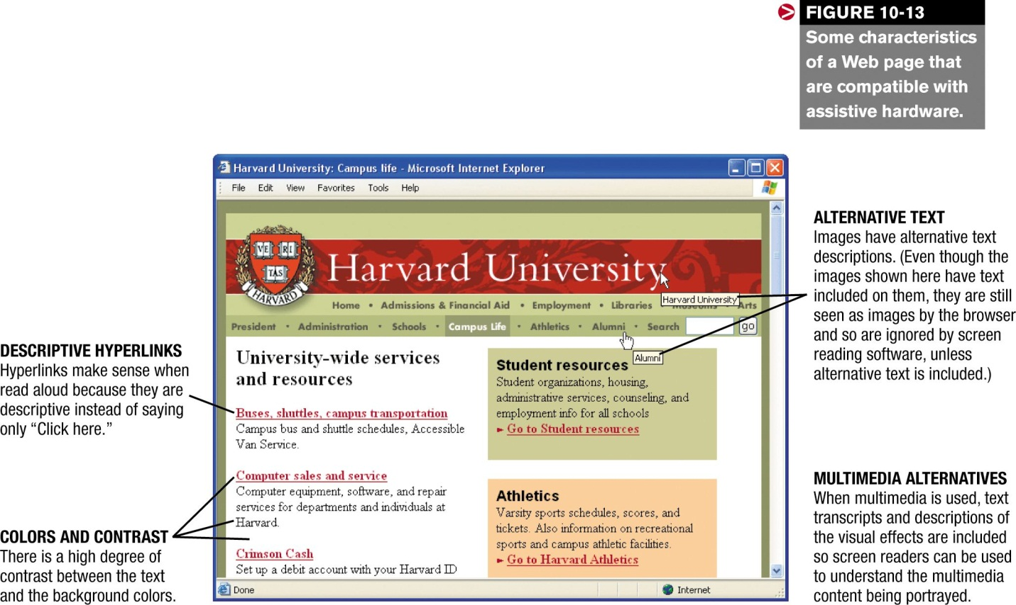  
In 1998, Congress amended the *Rehabilitation Act* to require federal agencies to make their electronic and information technology accessible to people with disabilities, specifically to make it able to be used as effectively by people with disabilities as by those without.  The law -- typically referred to as Section 508, for the section number in the U.S.  Code -- applies to all federal agencies and, consequently, all federal Web sites.   It was also hoped that passing this requirement would lead other companies to expand their Web content to make it more available to people with disabilities.  As Tim Berners-Lee, the inventor of the World Wide Web, once said, "The power of the Web is in its universality.  Access by everyone regardless of disability."

|  |
| --- |
| **SESSION 3.**  **Identify and save text, graphic elements and animation** |
| **Learning Outcomes** |
| * 1. Multimedia/web-based application text is used to align with agreed topic, purpose and target audience for the application and South African copyright and privacy laws. * 2. Graphic elements and animation are identified and saved according to agreed design specification and South African copyright and privacy laws. * 3. The text, graphic elements and animation are saved in a form that allows them to be integrated into the multimedia/web-based application. |

**MULTIMEDIA ELEMENTS**

Multimedia Web sites can consist of a variety of different multimedia elements.   The most common are discussed next.

**Text**

Text is an important part of most Web sites.  It is used to supply basic content, as well as to add text-based menus, and hyperlinks.   It is also frequently added to buttons, logos, banners, and other Web page graphics.  As discussed, text can be displayed in a variety of typefaces, colors, sizes, and appearances; a typeface is a collection of text characters that share a common design, such as the Times New Roman, Cooper Black, Arial, and Dom Casual typefaces illustrated in [Figure 10-2](http://www.mtsac.edu/~rpatters/CISB11/Chapters/Chapter_10/Figures/Fig10-02.jpg" \o "Click here to see Figure 10-2." \t "_blank).  Serif typefaces -- typefaces (such as Times New Roman) that have small lines called serifs on the edges of the letters -- tend to be more readable for large bodies of text, and so are traditionally used for this purpose.  Sans serif typefaces, such as Arial, don't have serifs and are frequently used for titles, headings.  Web page banners and other text elements that usually are formatted larger or with a more distinctive appearance.   
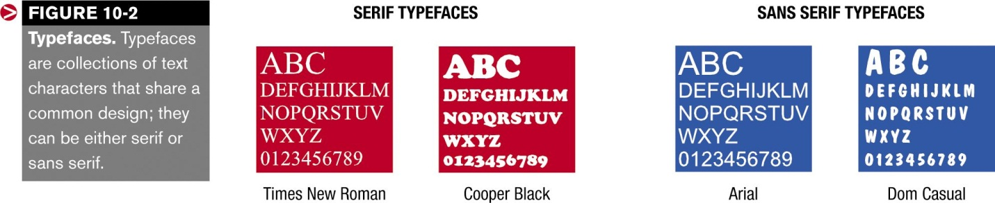  
There are a wide variety of typefaces available, and one typeface may convey an entirely different feeling than another typeface.  For example, Times New Roman is a traditional, business-like typeface, whereas Dom Casual is more whimsical and fun.  Consequently, when creating multimedia elements that contain text, it is important to select a typeface that matches the Web page and application for which it will be used.     
  
In addition to selecting an appropriate typeface, it is also important to select the appropriate font size.  Normal size is 12-point text -- it is not a good idea to use smaller text because it can be difficult to read.   Be sure not to make your text too large either because it will take up too much space on the screen.  You want to make sure enough information fits on the screen at one time to avoid annoying your users by making them have to scroll needlessly.     
  
Also, be sure to watch your color combinations.  A high degree of contrast between the text color and the Web page's background color results in the most readable text -- don't use dark text on a dark background or light text on a light background.   
  
When using Web page text, there is one additional important consideration: the computer and Web browser on which the Web page is displayed ultimately determine the typeface and font size used to display the text on a Web page.  Only the typefaces installed on a user's computer can be used to display Web page text, unless the typeface is sent embedded in the Web page.  And, although Web page developers can include alternative typefaces in the Web page instructions to be used if the specified typeface isn't available on the user's computer, the user still has the option of overruling font face, color, and size specifications and using his or her specified font characteristics instead.   So it is important to remember that when text is used, there is the chance that it will not be displayed exactly as intended.   
  
For these reasons, when a consistent text appearance is required on a Web site -- such as for a company logo or navigation buttons -- a graphical image is used instead.  Unlike regular text, text that is incorporated into an image is displayed the same on all computers, regardless of the user's browser settings (see [Figure 10-3](http://www.mtsac.edu/~rpatters/CISB11/Chapters/Chapter_10/Figures/Fig10-03.jpg)), because the text is part of the displayed image's file.  Images are discussed next.

**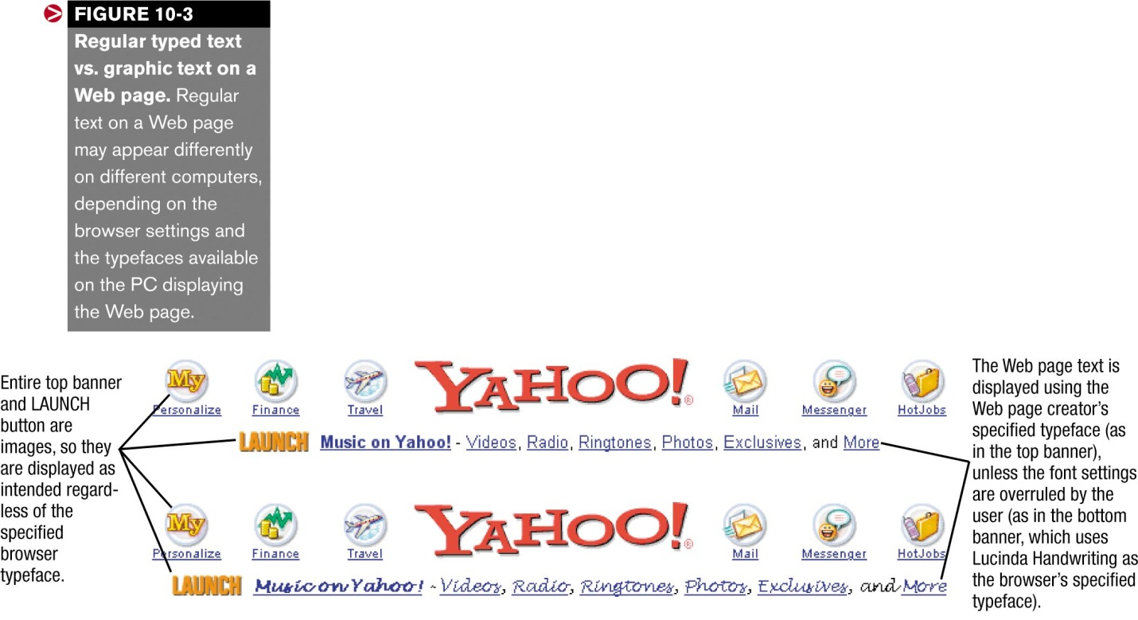**

**Graphics**

Graphics or *images* refer to digital representations of photographs, drawings, charts, and other visual images.  Unlike *animation* or *video* (discussed later in this chapter), graphics are unmoving, static images.   Graphics can be created by scanning a photograph or document, taking a picture with a digital camera, or creating or modifying an image in an image-editing program.  They can also be obtained as *clip art* or *stock photograph* images.     
  
*Clip art* consists of premade electronic images.  Some clip art is typically included with office suite programs and image-editing programs; it is also commonly available in collections on CDs, as well as from a variety of Web sites.  While most clip art must be purchased, it is usually *royalty-free*, which means it can be freely used in any document (such as a newsletter or Web page) without further payment or permission.   Some entirely free clip art is also available over the Internet (see [Figure 10-4](http://www.mtsac.edu/~rpatters/CISB11/Chapters/Chapter_10/Figures/Fig10-04.jpg" \o "Click here to see Figure 10-4." \t "_blank)).   
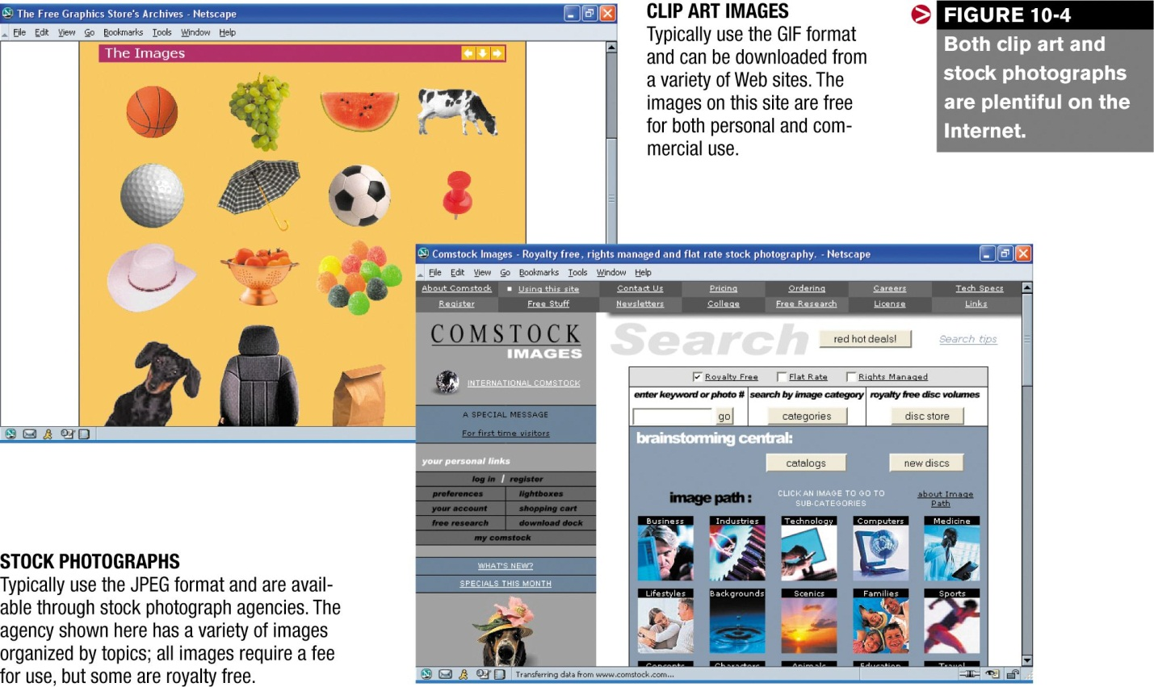  
*Stock photographs* are professional photographs available for use on Web pages and other types of documents; some are royalty-free, others have more restrictive usage requirements.  Stock photographs are sold both in collections and individually from stock photograph agencies.   
  
Graphics are available in many formats, such as *TIF*, *BMP*, *GIF*, *JPEG*, and *PNG*.  The (.TIF format is commonly used with scanned images, and the BMP format is used by Windows Paint and similar graphics programs.  Web page images are usually saved in either the GIF, JPEG, or PNG format.  These formats are explained in more detail next.

GIF

The *Graphics Interchange Format* (usually just referred to as GIF and saved with the file extension .gif) is the standard format for Web page images and is supported by all browsers that display images.   It is an efficient, compressed format in which images can contain up to 256 colors; a smaller palette size can help reduce the file size of the finished image.  The GIF format uses *lossless file compression*, so the quality of the image is not decreased when it is saved in the GIF format.  For a closer look at lossless file compression, see the How it Works box on page 425 of your textbook.   
  
GIF images are always rectangular, but can use a *transparent* background color to make the images appear to be non-rectangular (see  [Figure 10-5](http://www.mtsac.edu/~rpatters/CISB11/Chapters/Chapter_10/Figures/Fig10-05.jpg" \o "Click here to see Figure 10-5." \t "_blank)).   GIF images can also be *interlaced*, which means that the image is displayed initially at low resolution and its quality is progressively increased until it is displayed at full quality; non-interlaced GIFs are displayed top to bottom at full quality instead.   Even though an interlaced image doesn't actually load faster, interlacing enables the user to more quickly perceive what the image looks like; therefore, the image seems to load faster.   Transparency is usually set when the image is created; interlacing is typically designated when the image is inserted into a Web page.

**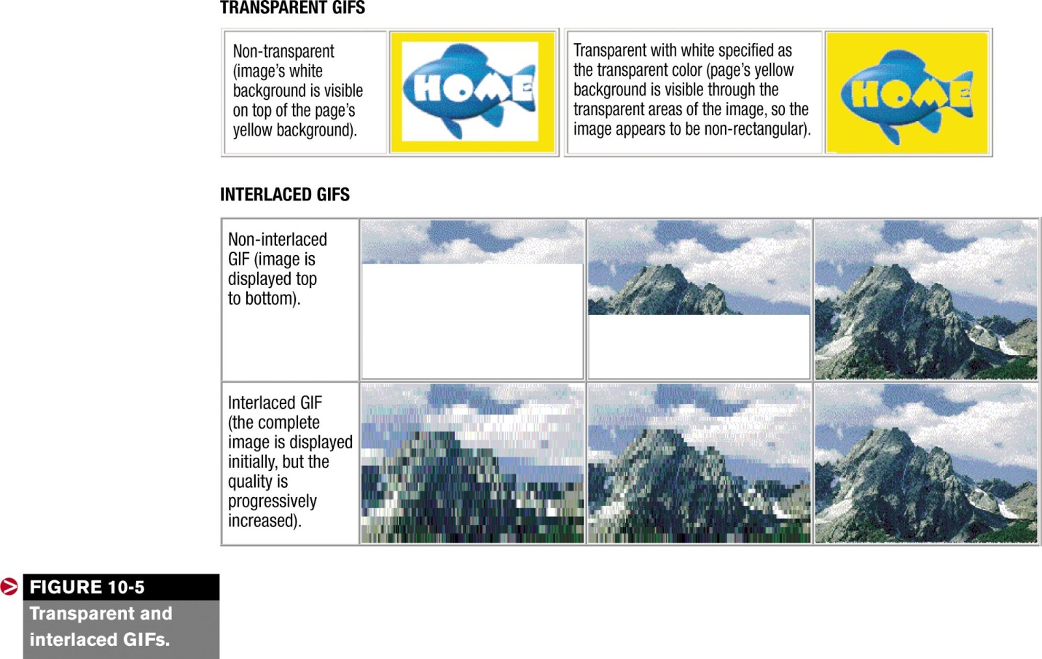**

**JPEG**

The *Joint Photographic Experts Group* format (usually just referred to as JPEG and saved with the file extension *.jpg*) is supported by all Web browsers that display images.  JPEG images are compressed using*lossy file compression*.  Consequently, image quality is lost during the compression process.   A compression amount from 0 to 100% is selected when the image is saved�the higher the compression, the smaller the file size but more quality is lost in the compression process, as illustrated in [Figure 10-63](http://www.mtsac.edu/~rpatters/CISB11/Chapters/Chapter_10/Figures/Fig10-06.jpg" \o "Click here to see Figure 10-6." \t "_blank).   
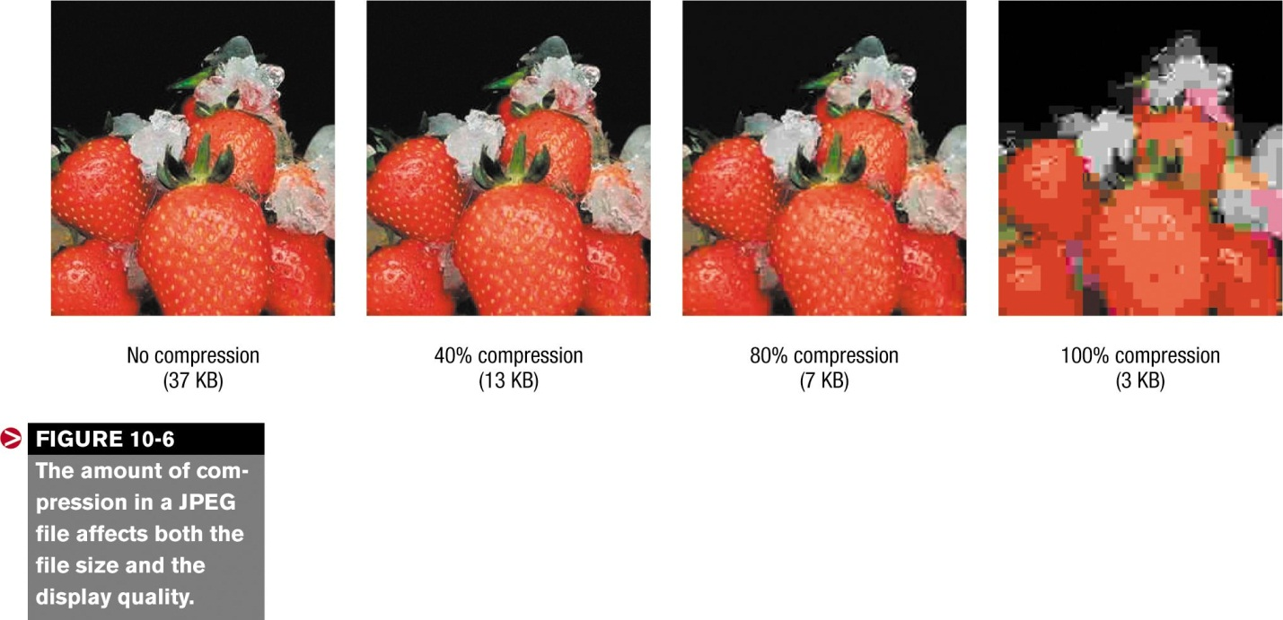  
JPEGs can be designated as *progressive*, which means they can display images initially in a low resolution version which is progressively improved, similar to interlaced GIFs.  JPEG images can contain more than 16 million colors (called true color), so this format is often used for photographs and other images that may require more than 256 colors.

**PNG**

The *Portable Network Graphics* format (usually just referred to as PNG and saved with the file extension *.png*) is a format specifically created for Web page images.  It was initially expected to eventually replace the GIF format, but it is still not widely used.   The PNG format uses lossless compression and the amount of compression cannot be specified, similar to GIF, but usually compresses more efficiently, which results in slightly smaller file sizes.   
  
PNG images can use a specific color palette of 256 colors or less (like GIF images), or can use true color (like JPEG images); PNG images can also be interlaced and transparent.

**Choosing a Graphic Format**

When creating an image, it is important to use the most appropriate graphic format.  Graphics for multimedia components need to be in a format compatible with the multimedia software being used, and Web page images should use as small a file size as possible to reduce loading time.  For Web pages, the GIF format is usually selected for *line art*, such as clip art, logos, navigation buttons, and so forth, although the PNG format could be used, if preferred.   
  
The JPEG format is usually used for photographs because JPEG images support true color and because the user is able to select the amount of compression used, which often results in a higher-quality image at a smaller file size than if the GIF or PNG formats were used.  A line art image and a photograph saved with each of these three formats is illustrated in  [Figure 10-7](http://www.mtsac.edu/~rpatters/CISB11/Chapters/Chapter_10/Figures/Fig10-07.jpg" \o "Click here to see Figure 10-7." \t "_blank); for the JPEG images in this figure, varying amounts of compression were used and the one that had the smallest file size but that still had acceptable quality was selected.   
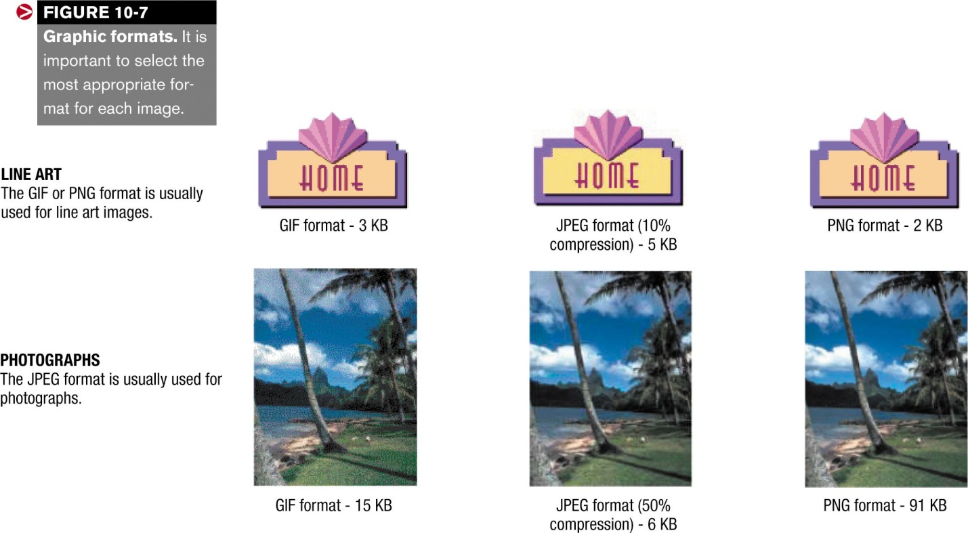  
It is also important to realize that the physical size of the image can greatly affect the file size when the image is saved.   Therefore, images should be sized to their appropriate display size before being inserted into a Web page.   When a Web page requires a very large image (such as to better show a product, home for sale, or featured piece of art), a *thumbnail image* can be used to save loading time.   Thumbnails are physically small versions of images that are linked to a corresponding full-sized image; when a thumbnail image is clicked, the full-sized image is displayed (see Figure 10-8).  The use of thumbnail images avoids increasing the page loading time for all users, when only some of the users may wish to view the full-sized images. 

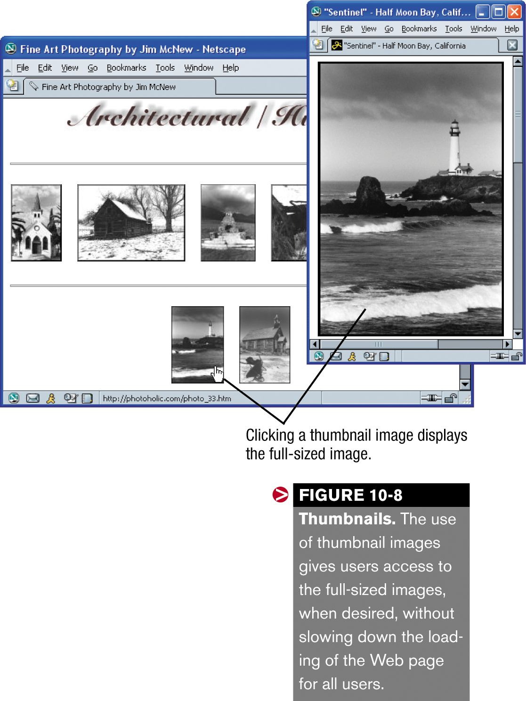

**Animation**

Animation is the term used to describe a series of graphical images that are displayed one after the other to simulate movement.   Cartoons on television are one example of animation; animating objects on Web pages so they move or change their appearance when pointed to is another.  Multimedia applications, both on and off the Web, frequently use animation.   To add simple animation to a Web page, Java applets and animated GIFs are frequently used.  A Java applet is a small program inserted into a Web page that performs a specific task, such as changing the values in a stock porfblio, scrolling text or images across the screen, and so forth.  An animated GIF is a group of GIF images stored in a special animated GIF file that is inserted in a Web page, similar to any other graphic.   The individual images contained in the animated GIFfile display one after another to simulate movement (see  [Figure 10-9](http://www.mtsac.edu/~rpatters/CISB11/Chapters/Chapter_10/Figures/Fig10-09.jpg" \o "Click here to see Figure 10-9." \t "_blank)).   Animated GIFs are frequently used to change the images displayed in an onscreen advertising banner.   
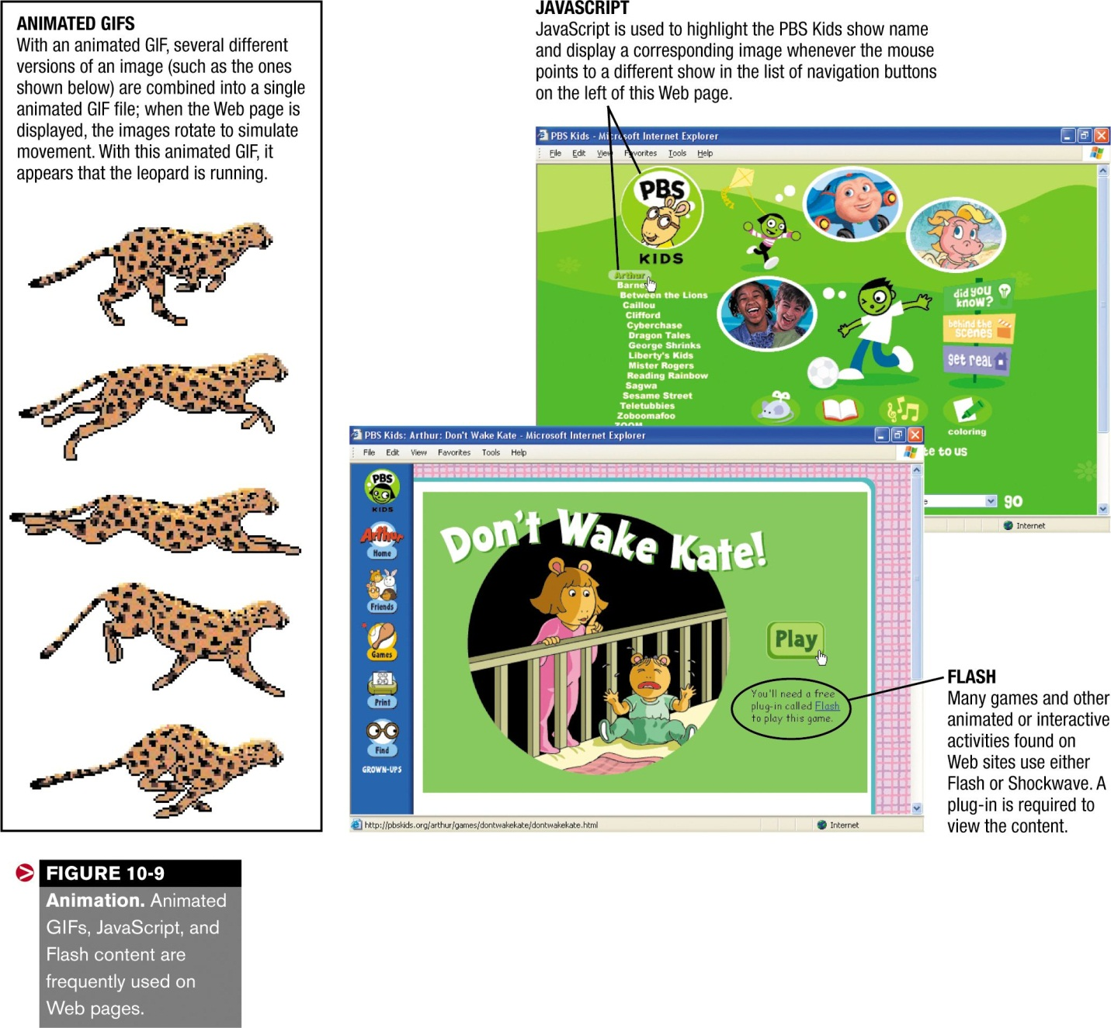  
For more complex animations, *Shockwave*, *Flash*, *JavaScript*, or *ActiveX* animations are typically used; these types of animation require a plug-in (a small program that adds additional capabilities to your browser) to view.  Of these, JavaScript and Flash are two of the most widely used animation formats.  JavaScript is commonly used to build interactivity into a Web page, such as having text or an image change as a menu item is pointed to, as in [Figure 10-9](http://www.mtsac.edu/~rpatters/CISB11/Chapters/Chapter_10/Figures/Fig10-09.jpg).  Flash has been used consistently to create individual animated components found on Web pages, such as games, tutorials, and animated introductions that are played when a Web page is loaded; it is now beginning to be viewed as a viable development tool for overall Web development and is being used in place of, or in conjunction with, JavaScript to add interactivity to a Web site.   Animation and interactivity can also be achieved using *Dynamic HTML (DHTML)* and *programming languages* ).   
 One interesting type of animation appearing in an increasing number of Web site applications is the digital character,

**Audio**

Audio includes all types of sound, such as music, spoken voice, and sound effects.  Sound is commonly found on Web sites in the form of background music, downloadable music, and as part of games, tutorials, and other multimedia elements.   Audio can be recorded using a microphone or MIDI instrument; it can also be captured from CDs or downloaded from the Internet.  Remember that audio files require a great deal of storage space, so compression methods are frequently used to reduce their file size.   
  
Audio is often played automatically when a particular event occurs, such as background music playing when the home page of a site is first displayed, narration or other audio content starting when a Flash or Shockwave activity is loaded, or a sound effect playing when the mouse points to or clicks a navigation button.   Web pages can also contain hyperlinks to audio files so they won't play unless the user clicks that link.  Audio files on Web pages are commonly played with plug-ins or player programs, such as *QuickTime, Windows Media Player*, or *Real One Player*.   
  
As mentioned, audio files on a Web page can be in the form of *streaming audio*.  In this format, a small portion of the audio file is downloaded and *buffered* (placed in memory or temporarily stored on the hard drive), and then begins playing while the remainder of the file downloads simultaneously.   Because it allows the user to see or hear the file's content significantly faster than if the entire file had to be downloaded first, it is recommended to use the streaming approach for all large audio and video files used with Web pages.   
  
Some of the most widely used audio file formats are listed next 

* *.wav* -- *Waveform* format; not compressed, so usually results in l arge file sizes.  The format in which most CD music is stored.
* *.mp3* -- *Motion Picture Experts Group Audio Layer 3* format; very efficient, high-quality compressed audio.  Waveform files can be converted to MP3 format to reduce their file size.
* *.midi* -- *Musical Instrument Digital Interface* format; used for files created with a MIDI device.
* *.aiff* -- *Audio Interchange Format File*; used for Macintosh waveform files.
* *.aac* -- *Advanced Audio Coding*; the Motion Picture Experts Group Audio Layer 4 format, a newer alternative to MP3 for both fixed and mobile Web applications.

**Video**

Video differs from animation in that it begins as a continuous stream of visual information that is broken into separate images or *frames* when the video is recorded.  When the frames are projected -- typically at a rate of 30 frames per second -- the effect is a smooth reconstruction of the original continuous stream of information.  As you might imagine, at 30 images per second, the amount of data involved in saving a video file can require a substantial amount of storage space.  Consequently, video data -- like audio data -- is often compressed.  A variety of compression standards exist.   Some of the most common video file formats are listed next; most can be played using a standard media player, such as Windows Media Player or Real One Player. 

* *.avi* -- *Audio-Video Interleave* format; a standard video file format developed by Microsoft.
* *.mpeg* -- *Motion Picture Experts Group* format; high-quality, compressed video.
* *.mov* -- *QuickTime* format; versatile format developed by Apple and widely used to distribute video over the Web.
* *.rm* -- *Real* format; highly compressed format used for streaming video files.

Video that is to be incorporated into a multimedia Web site can be recorded using a standard (analog) video camera and then converted to digital form as it is input into a computer, but it is more commonly recorded in digital form using a digital video camera.  Web page video applications include delivering video clips of television shows, news broadcasts, and corporate speeches; facilitating panoramic video tours of facilities or products;' and more.  Similar to audio files, streaming video is frequently used on Web pages to speed up delivery; just like streaming audio files, streaming video files begin playing once a portion of the video has been downloaded.

|  |
| --- |
| **SESSION 4.**  **Create multimedia/web-based computer application scripts.** |
| **Learning Outcomes** |
| * 1. A logic diagram of the scripts is demonstrated in the specified outcome * 2. The operating environment of the computer and associated applications and software are configured so that it may be used as outlined in the plan. * 3. The script is written using standard features of the scripting language. * 4. The scripts are tested, errors identified and corrected through most likely conditions. |

**MULTIMEDIA WEB SITE DEVELOPMENT**

Once a Web site has been carefully designed, it is time to create it.   This process is called *Web site development*.   The development of a Web site can be performed in-house (if employees with the appropriate skills and appropriate software are available) or it can be outsourced to a professional Web developer.   In either case, the development process of a multimedia Web site includes three basic steps: 

* Creating the multimedia elements.
* Creating the Web Site.
* Testing and maintaining the site.

These three steps, along with the various types of software that can be used during each step, are discussed next.

**Creating the Multimedia Elements**

Before the actual Web pages are created, it is a good idea to create all of the individual multimedia elements (such as graphics, animated components, video files, and audio files) that will be used in the site.  To accomplish this, typically several different programs are used, such as *graphics software* to create or modify images, *animation software* to create animated elements, and *audio editing* and *video editing software* to create finished sound and video clips.   
  
As the elements are finished, they should be saved in the appropriate size, resolution, and file format so that they are ready to be inserted into the Web pages or animation sequences.

**Creating the Web Site**

Most Web pages today are written in a markup language, a coding system used to define the structure, layout, and general appearance of the content of a Web page.  When a markup language is used, *markup tags*are inserted around the Web page content to identify where elements are to be displayed and their general appearance.  JavaScript and other scripting languages can be used to add dynamic content to a Web page, and Web site authoring software is frequently used to create an entire site, tying together all the marked up Web pages, scripts, and multimedia elements contained within a site.

**Hypertext Markup Language (HTML)**

The most common markup language for Web pages is HTML (Hypertext Markup Language).  HTML uses HTML tags�text-based codes embedded into a Web page -- to indicate where an effect (such as larger text, bolded text, or centering) should begin and where the effect should end.  HTML tags are also used to specify where graphical images, hyperlinks, video clips, and so forth are to be located on the page.  When a Web page is created -- using either a word processor, text editor, or Web site authoring software -- the HTML tags are inserted in the appropriate locations within the Web page's text.  Some tags are used alone; others appear in pairs.  For example, the HTML tag turns holding on for the text that follows the tag until the tag is reached, so the following HTML statement   
  
< b >This text is bolded.< /b >   
  
would produce the following when viewed with most Web browsers.   This text is bolded.   
 **HTML tags are commonly used to perform such tasks as:**

* Assigning a title to a page.
* Identifying text as a heading (for example, first-level head, second-level head, and so on).
* Marking the ends of paragraphs.
* Assigning a typeface, relative size (smaller or larger than normal-sized text, for instance), or font style (such as italic or bold) to text.
* Making text or images hyperlinks.
* Identifying where elements to be inserted into a Web page (such as graphics, animation, video clips, and sound files) should be displayed.
* Specifying the layout of tables and frames.
* Identifying keywords to be associated with the page (used by search sites).

It is important to realize that with a markup language like HTML, the Web browser and computer being used to display the Web page ultimately determine what the Web page will look like.  Text that looks like 36-point boldfaced text on a Web page as it is being developed might be transmitted over the Internet in regular type marked up as "very large" and "bold" text.  The receiving PC's browser then determines the particular font to be used to display the text, bolds the text if possible, and figures out how large "very large" type should be.  A Web page and its corresponding HTML code are shown in  [Figure 10-14](http://www.mtsac.edu/~rpatters/CISB11/Chapters/Chapter_10/Figures/Fig10-14.jpg" \o "Click here to see Figure 10-14." \t "_blank), along with some common HTML tags.

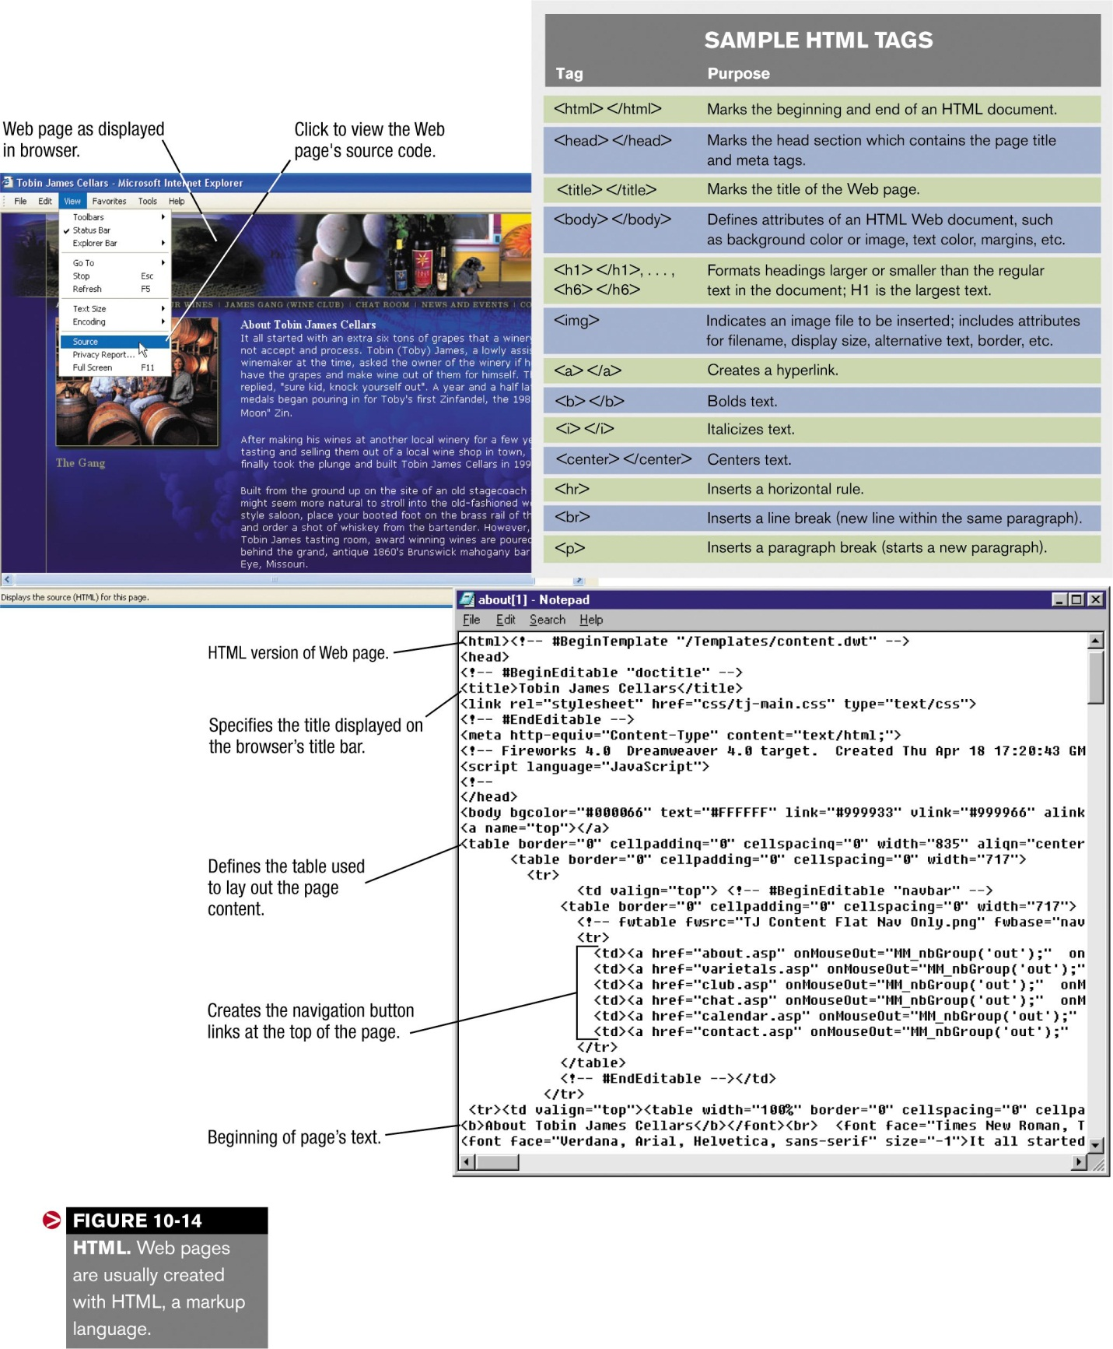

**Other Markup Languages**

In addition to HTML, other markup languages are available for specific purposes, such as adding dynamic content or creating pages for mobile devices.  Some of the most widely used markup languages that can be used as a replacement for, or in conjunction with, HTML to create Web page content are discussed next.

**Dynamic HTML (DHTML)**

Dynamic HTML (DHTML) is used to add dynamic capabilities and interactivity to Web pages, such as objects that move, grow, shrink, appear, disappear, or change color based on the user's mouse actions.  It enables Web page developers to create pages that change in layout and content without having to continually download new information from the Web server, making the page more exciting but still efficient.   Versions 4 and higher of Netscape and Internet Explorer support some forms of DHTML.  Some DHTML features are expected to be built into future versions of HTML.

**Extensible Markup Language (XML)**

XML (Extensible Markup Language) is a set of rules for exchanging data over the Web.  It's called "extensible" because the markup can be customized for one or more particular purposes, such as being displayed with a variety of types of PCs or other access devices.  This is possible because XML doesn't address the formatting of Web page content, just the content itself.   So the device being used to access the content displays it in a form appropriate for that device.  XML also allows Web page developers to create their own customized XML tags, as needed.  It is increasingly being used to manage the content of databases tied to Web pages and allows for easy retrieval of Web page data by applications such as RSS newsreaders, which combine headlines for a specified topic extracted from a huge collection of Web pages, mainly news sources; clicking a headline displays that Web page.

**Extensible Hypertext Markup Language (XHTML)**

XHTML (Extensible Hypertext Markup Language) is a hybrid between HTML and XML.  XHTML is commonly used with Internet appliances and mobile devices and is similar to HTML but is stricter and more portable.  Since XHTML is a markup language written in XML, it is an XML application.   The newer XHTML 2.0 standard is thought by many to be the next generation of HTML.  XHTML 2.0 includes new tags for line breaks, embedded objects, and headings, as well as a new forms model expected to be a large improvement for businesses maintaining Web-based applications.

Wireless Markup Language (WML)

Wireless Markup Language (WML) is a language similar to XML that is used with pages to be displayed on a WAP-enabled wireless device, such as a smart phone or pager.   To display Web content, a WAP-enabled browser -- sometimes called a microbrowser -- is used.

**Scripting Languages**

For Web pages with a great deal of dynamic content, a scripting language is typically used.  Such languages enable you to build program instructions, or scripts, directly into a Web page's code to add dynamic content or database integration.   Scripting languages are typically easy to use.   Three of the most popular scripting languages are JavaScript, VBScript, and Perl.

**JavaScript**

JavaScript was originally developed by Netscape to enable Web authors to implement interactive Web sites (see  [Figure 10-15](http://www.mtsac.edu/~rpatters/CISB11/Chapters/Chapter_10/Figures/Fig10-15.jpg" \o "Click here to see Figure 10-15." \t "_blank)).   Named JavaScript because it resembles the full Java programming language, JavaScript was developed independently from Java.  When using JavaScript, it is important to realize that not all JavaScript commands work with all browsers.  Because of this, make sure that the important features you add to your site with JavaScript are not browser specific.  JavaScript is commonly used to add interactive content to Web pages, such as pop-up windows or text or objects that are displayed when the mouse points to a particular object, button, or menu item on a Web page.

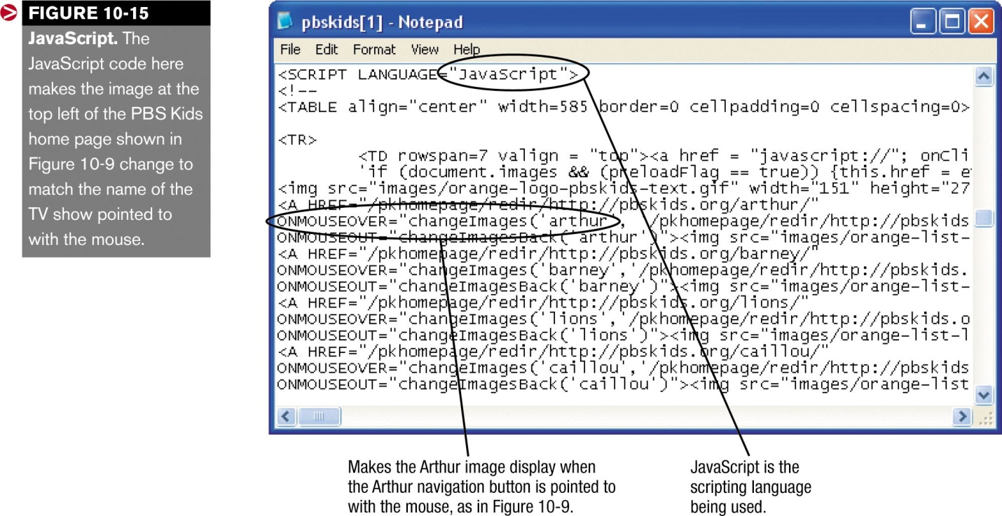

**VBScript**

Another scripting language in use today is VBScript (Visual Basic Scripting Edition), a scripting language developed by Microsoft.   VBScript is based on the Visual Basic programming language.   VBScript is used for similar purposes as JavaScript -- it enables Web developers to include interactive elements, such as pop-up content, on their Web pages viewed with the Internet Explorer browser.  Individuals who are already familiar with Visual Basic can easily incorporate VBScript content into their Web pages.

**Perl**

Short for "Practical Extraction and Report Language," Perl was originally developed as a programming language designed for processing text.  Because of its strong text-processing abilities.  Perl has become one of the most popular languages for writing CGI scripts -- scripts that are often used to process data entered into Web page forms tied to databases,

**Other Content Development Tools**

Two content development tools not yet discussed are **ActiveX and VRML**.  These tools are commonly used in multimedia Web environments.  Another useful Web development tool is the ability to create a Web archive in order to transmit an entire Web site at one time, such as via e-mail.   Today, this is usually accomplished with MHMTL.

**ActiveX**

ActiveX, developed by Microsoft Corporation, is a set of controls that can be used to create interactive Web pages.   In a nutshell, ActiveX extends object linking and embedding (OLE) -- also developed by Microsoft and adopted widely as a standard by the software industry -- to work on the Web.   As discussed, OLE permits you to integrate content from two or more programs, such as copying and either pasting or linking spreadsheet objects (a chart or group of cells, for instance) into your word processing document.   
  
In other words, OLE is a method of nesting OLE-supported applications inside each other as you are preparing a document.   ActiveX, when used to implement OLE on the Web, allows you to do such things as launch your word processor or spreadsheet from your Web browser and share objects among applications.  It also enables your Web browser to play special content on Web pages; for instance, the Shockwave ActiveX control can play interactive multimedia presentations that are created in the Shockwave format.   
  
ActiveX content can be virtually any type of object -- a Java applet, a C++ program, an animation, or a PowerPoint presentation.   Software that supports ActiveX sets up any such object as an interactive component on the Web page; ActiveX is essentially the "glue" that holds the different page components together.   
  
What ActiveX in effect allows Web publishers to do is grab files from their hard disks that are suitable for the Web and drop them directly into HTML documents.  Such a capability is especially useful for office intranets, for which a great deal of potential Web page content may already exist in the form of office documents.  To view ActiveX content, your browser must either directly support it or have access to an appropriate plug-in.

**Virtual Reality Modeling Language (VRML)**

Short for "Virtual Reality Modeling Language," VRML is a specification for displaying three-dimensional objects on Web pages.  It is essentially the 3-D equivalent of HTML.   Piles written in VRML have the extension .wrl (short for "world").  To view these files, you need a VRML browser or a Web browser with a VRML plug-in.   VRML objects, such as cars, homes, and other photo-realistic 3-D objects, can be rotated as desired, to be viewed from any angle.  An example of a VRML application (touring a model home by moving the mouse in the desired direction) was shown in  [Figure 7-22](http://www.mtsac.edu/~rpatters/CISB11/Chapters/Chapter_10/Figures/Fig07-22.jpg" \o "Click here to see Figure 7-22." \t "_blank).

**MHTML (MIME HTML)**

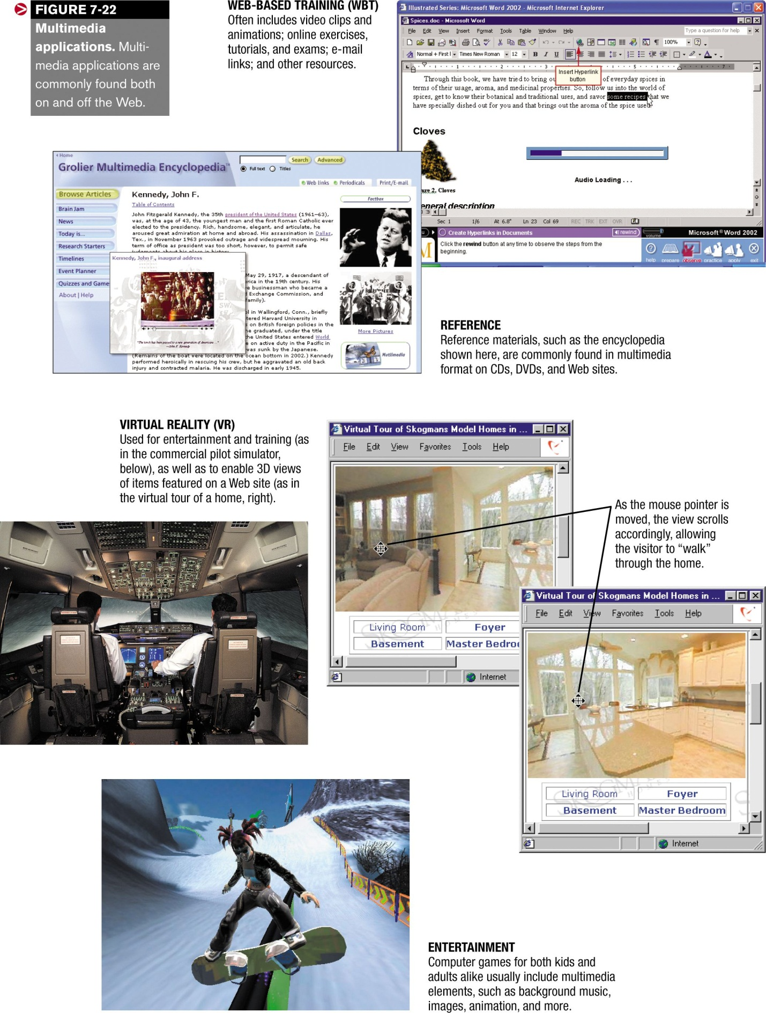

MHTML (MIME HTML) is a format for transmitting all the elements of a Web site (text, graphics, sound files, animated items, etc.) together as a single file.  The MHTML file (also referred to as an encaspulated aggregate HTML document) uses the MIME standard to keep track of the individual elements contained in the file and can be sent via e-mail.

|  |
| --- |
| **SESSION 5.**  **Assemble a multimedia/web-based application including scripts.** |
| **Learning Outcomes** |
| * 1. The multimedia/web-based application is assembled using the saved text, graphics and animation, written application scripts and planned specification and user requirement. * 2. The function and content of the application are consistent with the design specification and specified computer system environment. |

**Web Site Authoring Software**

Web pages can be created by typing the page's text, HTML tags, JavaScript code, and other needed content in any word processor or text editor.  However, creating complex Web pages in this manner (such as those containing tables, frames, animation, or input forms that are linked to a database) is a very difficult task.   Web site authoring software (also called Web site development software) makes the job of creating Web pages and complete Web sites much easier.  Instead of entering the HTML tags by hand, most Web site authoring programs automatically generate the appropriate HTML statements when options are selected from menus, toolbar buttons are clicked, or the developer otherwise specifies what the Web page should contain and look like.     
  
Similarly, as menu options are selected, the appropriate JavaScript, DHTML, or other code used to add animation or interactivity is generated.  Some of the most popular Web site authoring programs are *Adobe GoLive, Microsoft Frontpage*, and *Macromedia Dreamweaver* (see  [Figure 10-16](http://www.mtsac.edu/~rpatters/CISB11/Chapters/Chapter_10/Figures/Fig10-16.jpg" \t "_blank" \o "Click here to see Figure 10-16.)).   
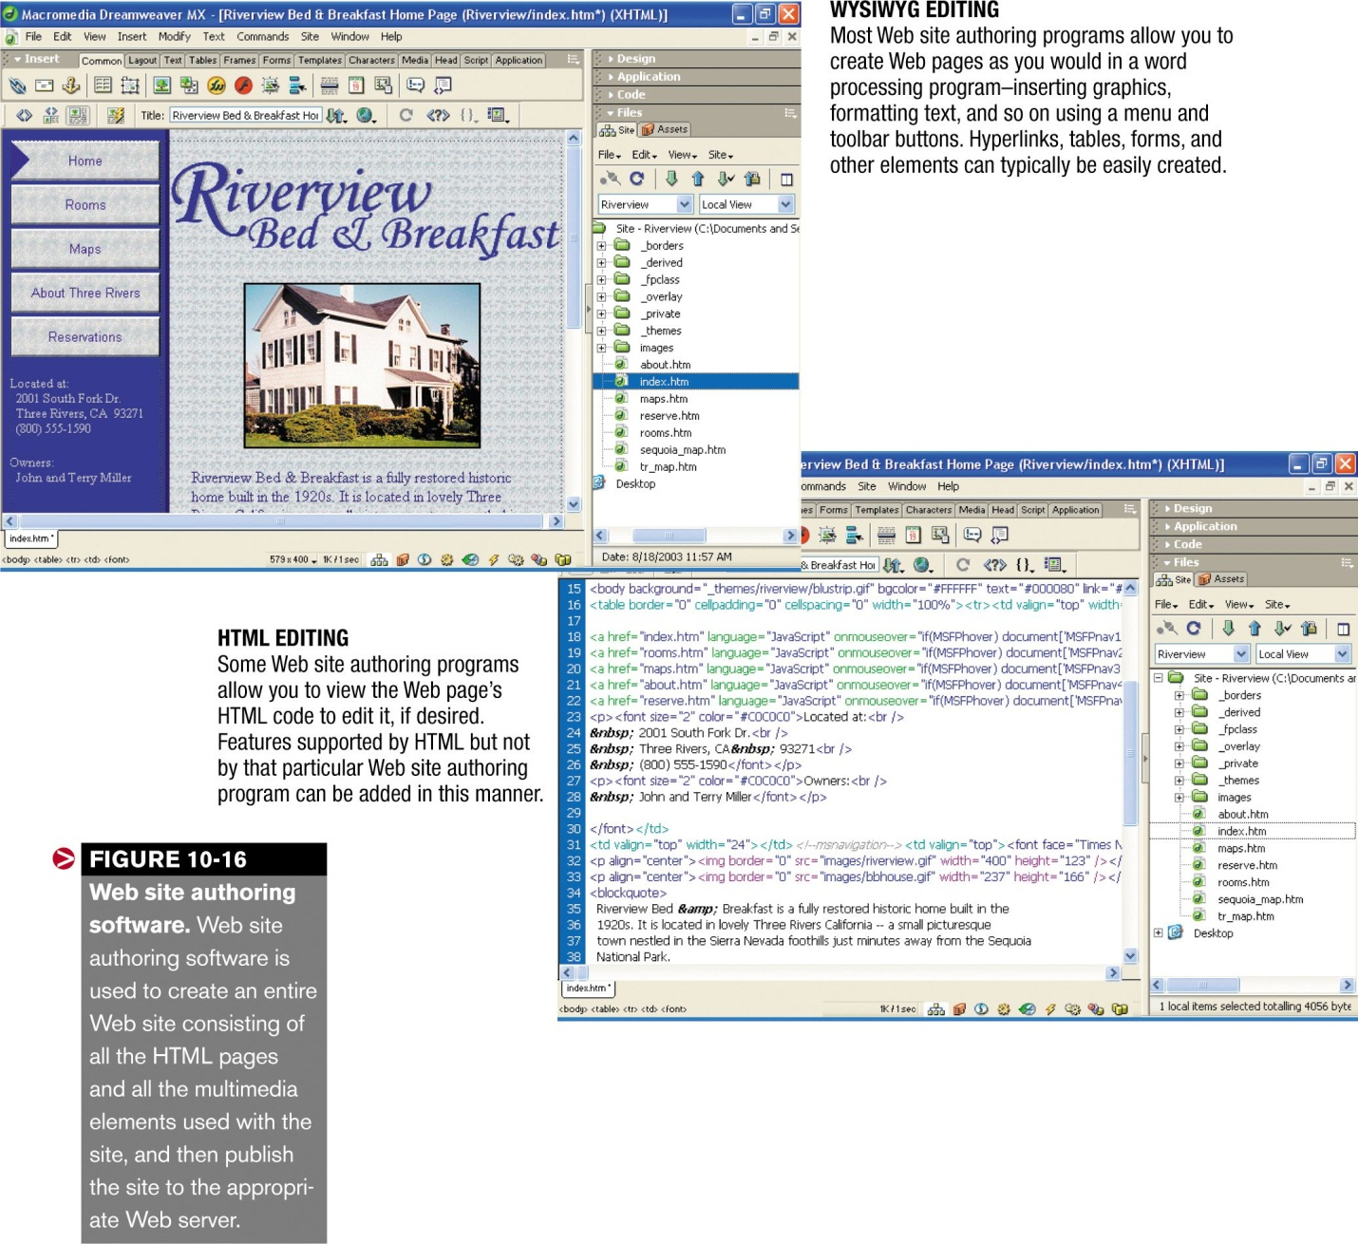  
Web site authoring programs allow you to create an entire cohesive Web site -- not just individual pages.  This allows effects, styles, backgrounds, and navigational tools to be applied to an entire site at one time, saving time and increasing consistency at the same time.  In addition, many Web site authoring programs allow you to easily include forms and database connectivity for more dynamic interactions with your visitors, and include other helpful development tools, such as tests for *broken links* (links to non-existent Web pages) and accessibility tests.  Once the entire site is created, the program can be used to quickly publish the entire site onto the appropriate Web server.   
  
In addition to text and graphics, Web site authoring programs virtually always have the capability to include a wide variety of other multimedia elements, such as Shockwave and Flash animations, animated GIFs, video clips, and audio clips.

**Testing and Maintaining the Site**

Once a multimedia Web site has been created, it must be thoroughly tested before allowing it to go "live" by publishing it to a Web server.  Each and every hyperlink needs to be clicked to ensure it takes the user to the proper location and every possible action (such as clicking or pointing to) that could take place with an animated element should be tested.  Complex animations (such as games and tutorials) should be tested individually before they are inserted into the Web page; after inserting the animation into a Web page, that page should be tested to ensure the animation works correctly.   
  
Ideally, Web site testing should take place on a variety of computers using different operating systems, browsers, and screen resolutions, and with a diverse selection of users.   The testers should be a variety of ages and have a wide range of computer abilities.  If possible, an observer should discretely watch the testers and take note of any point during the testing time that users seem confused or end up somewhere they didn't intend to go.  Finished Web pages should also be checked for spelling and grammatical errors.  Your application should appear professional, so be sure to proofread each page or screen carefully.   Many Web site authoring programs include spelling and hyperlink checkers to assist you with testing, but these electronic tools shouldn't replace careful proofreading and testing.   
  
After the mechanics of a Web site are tested, companies should consider subjecting their site to a "stress test." These tests are frequently performed by an outside agency and examine the capacity of the site and how many visitors and orders it can handle at one time.  Although a fairly new type of service, it is important for large e-commerce sites -- one industry estimate is that Web sites typically only handle about 20% of the traffic that the organization expects the site to handle.  There are also software programs an organization can acquire to continuously monitor its site for problems and bottlenecks.   
  
Once a site is up and running, the development process isn't over.   As mentioned earlier, Web sites should be regularly updated to keep them current and interesting.  Web sites should also be evaluated on a regular basis to locate areas needing improvement, new problems that have become apparent, and so forth.   Hyperlinks to external Web sites need to be checked on a regular basis, because the pages could be moved or become inappropriate for that link.  If, at some point, it appears that the site needs a major overhaul, the design and development process should start over from the beginning.

**THE FUTURE OF WEB-BASED MULTIMEDIA**

Although no one knows exactly what types of multimedia will be available in the future, it's a safe bet that it will be even more exciting and more embedded into everyday events than at present.   New types of multimedia will likely be developed to fit our growing need for mobile content and, as Internet users continue to move to broadband, expect to see multimedia Web sites and television merge even more closely together.  Game boxes (such as Xbox, Sega Dreamcast 2, and Sony PlayStation 2) already have some Internet and multimedia capabilities built-in, and interactive TV and video-on-demand may soon be the norm.

**SUMMARY**

**What is Web-Based Multimedia?**

Multimedia is the integrated use of more than one type of media, such as text, graphics, video, animation, and sound.   Multimedia applications are usually interactive.   With today's fast computers and Internet connections, multimedia applications are frequently found on Web pages.

**Advantages and Disadvantages of Using Multimedia**

One major advantage of using multimedia is that it appeals to a wide variety of people and complements different learning styles.  Multimedia tends to hold users' interest more than single media applications and it makes some ideas easier to convey.     
  
Disadvantages associated with multimedia Web sites are cost, access speed, and issues related to differing platforms, browsers, and Internet connection speeds.

**Multimedia Elements**

Multimedia applications typically contain text in a variety of typefaces and appearances.  Text is used to deliver content, as well as for instructions, menus, hyperlinks, and more.   Serif typefaces are commonly used for large sections of text; sans serif typefaces are more frequently used with titles and headings.  When a consistent text appearance is important for Web pages, the text is often rendered as a graphic, so it will look the same for all users.   Other types of graphics include photographs, drawings, charts, and other static images.  Already created clip art and stock photographs are widely available for purchase or downloading via the Internet.   
  
Common graphic formats include GIF (Graphics Interchange Format) and PNG (Portable Network Graphics) for line art images, and JPEG (Joint Photographies Experts Group) for photographs.   Other possible formats include T1F for scanned images and BMP for Paint images.  Animation consists of a series of graphical images displayed one after the other to simulate movement.   Java applets, animated GIFs, Dynamic HTML (DHTL), and JavaScript Web applications are examples of animation.   Audio includes all types of sound (such as music, spoken voice, and sound effects), and video is a continuous stream of visual information captured by a series of separate images or frames.   Audio, video, and graphics are frequently compressed to reduce the finished file size.

**Multimedia Web Site Design**

When designing a multimedia Web site, careful planning is essential to ensure an interesting and intuitive site that is attractive and easy to use.  Web pages should also be efficient and versatile enough to be used with multiple browsers and platform configurations.  Early steps in the design process include determining the intended audience, primary objectives, basic layout, and navigational structure for the site or application.  Tools such as flowcharts, page layouts, and storyboards can be used during the design process.  Features that require a specific browser or infrequently used plug-ins should be avoided whenever possible; high-bandwidth items should be used in moderation and be optional (such as a thumbnail image or link to a video file), if possible.   There are a number of navigational tools that can be used when creating the navigational structure of the site.   In addition, compatiblility with the various devices that might be used to access the site, as well as with assitive hardware, should be considered.

**Multimedia Web Site Development**

Once a multimedia Web site is designed, the development process can begin.  Necessary tasks include creating the multimedia elements to be used in the site, creating the site itself, and testing the finished product.  To create multimedia elements, graphics software (such as drawing, painting, and image-editing programs), animation software, and audio and video editing software can be used.  Web sites can be created with a markup language, such as HTML (Hypertext Markup Language), which use HTML tags to indicate text characteristics, page layout, hyperlinks, and more.   
  
Other options include Dynamic HTML (DHTML), XML (Extensible Markup Language), XHTML (Extensible Hypertext Markup Language), Wireless Markup Language (WML), JavaScript and other scripting languages.  Once the individual elements have been created, they can be inserted into Web pages.  Web site authoring software can be used to more easily create the site and tie all the site elements together.  After the site has been completed, it must be thoroughly tested to ensure all features and links work, and that it is compatible with as many different types of computers, platforms, operating systems, and browsers as possible.

**The Future of Web-Based Multimedia**

In the future, multimedia will likely be even more commonplace and integrated into our everyday lives.   Trends such as the convergence of TV and the Internet will lead us in that direction.  How fast this evolves depends, in part, on how soon fast home broadband Internet access becomes the norm.